Name: Monisha K
Reg no: 192421098
Course Code: ITA-0304
Course: Mobile Computing
CO2 ASSESSMENT TOOL 2
1. Figma-Based Mobile IP Communication Workflow Analysis (BL4 – Analyze)
Design an interactive Figma prototype illustrating the complete workflow of Mobile IP communication
when a Mobile Node moves from its Home Network to a Foreign Network. Your design should include
the Home Agent (HA), Foreign Agent (FA), Correspondent Node (CN), Care-of Address (CoA),
Registration Process, and Packet Tunneling.
Analyze the communication process by identifying:
- The purpose of each network component.
- Points where packet delay or packet loss may occur.
- The effect of node mobility on communication performance.
- Possible improvements to reduce latency.
OUTPUT:
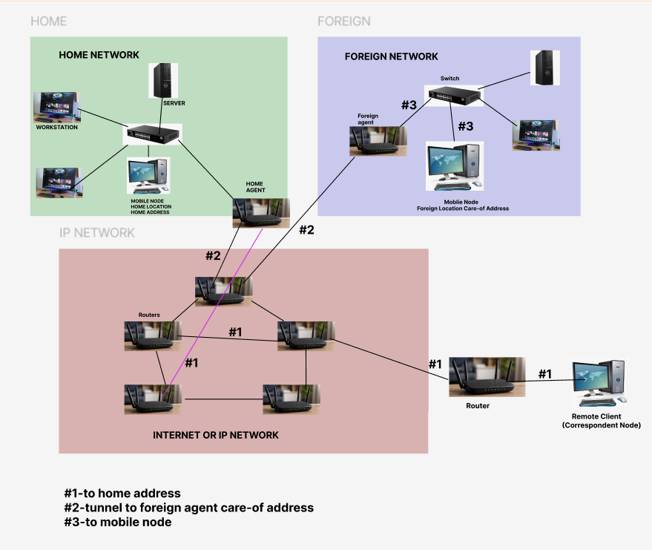

2. Comparative Network Architecture Design Using Figma (BL4 – Analyze)
Using Figma or draw.io, create a comparative architectural diagram showing both a Cellular Wireless
Network and a Mobile Ad Hoc Network (MANET) operating in the same smart city environment.
Analyze the architectures by comparing:
- Infrastructure dependency.
- Routing mechanisms.
- Scalability.
- Fault tolerance.
- Mobility support.
- Suitable application scenarios.
Highlight the advantages and limitations of each architecture through annotations in your design.
OUTPUT:
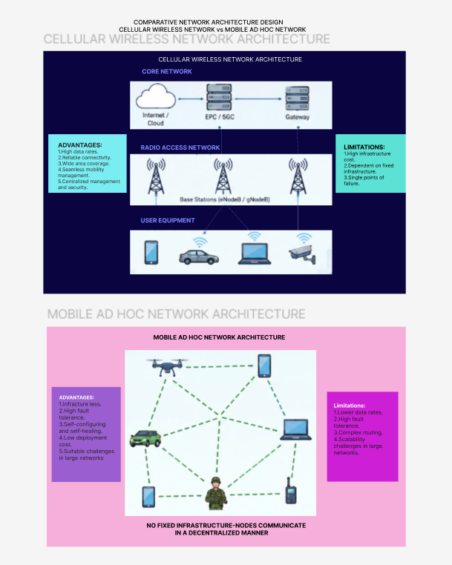

3. Routing Protocol Visualization and Analysis (BL4 – Analyze)
Develop an interactive visualization using Figma, Mermaid.js, D3.js, or any visualization framework
illustrating the operation of one Proactive Routing Protocol and one Reactive Routing Protocol in a
mobile wireless network.
Analyze:
- Route discovery process.
- Route maintenance mechanism.
- Routing overhead.
- Delay in establishing communication.
- Performance under high node mobility.
Include a comparative summary explaining which protocol performs better under different mobility conditions.
OUTPUT:
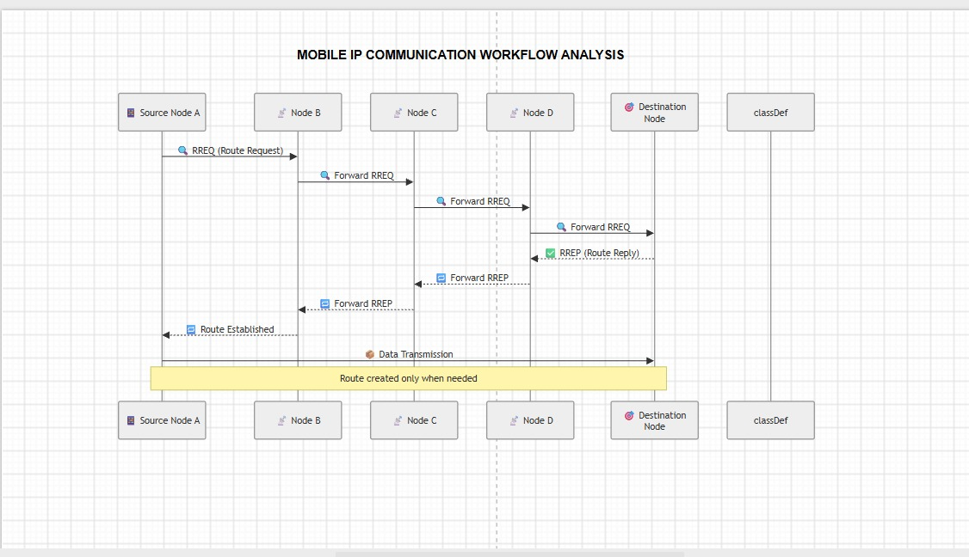
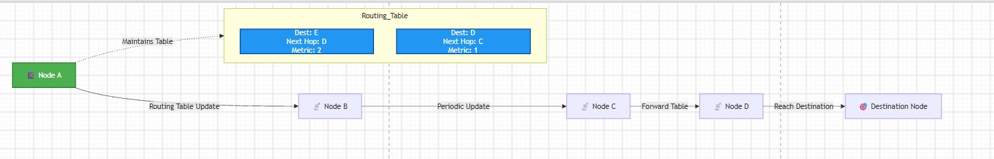

4. Design a Smart Healthcare Mobile IP system using Figma that enables doctors, ambulances, hospitals,
and patients to remain connected while moving across different wireless networks.
Analyze:
- How Mobile IP maintains uninterrupted communication.
- Challenges during handoff between networks.
- Security vulnerabilities during mobility.
- Possible design improvements to increase reliability.
Provide navigation between screens demonstrating different mobility scenarios.
OUTPUT:
